MDPCC ASSIGNMENT 01

1.Create VPC

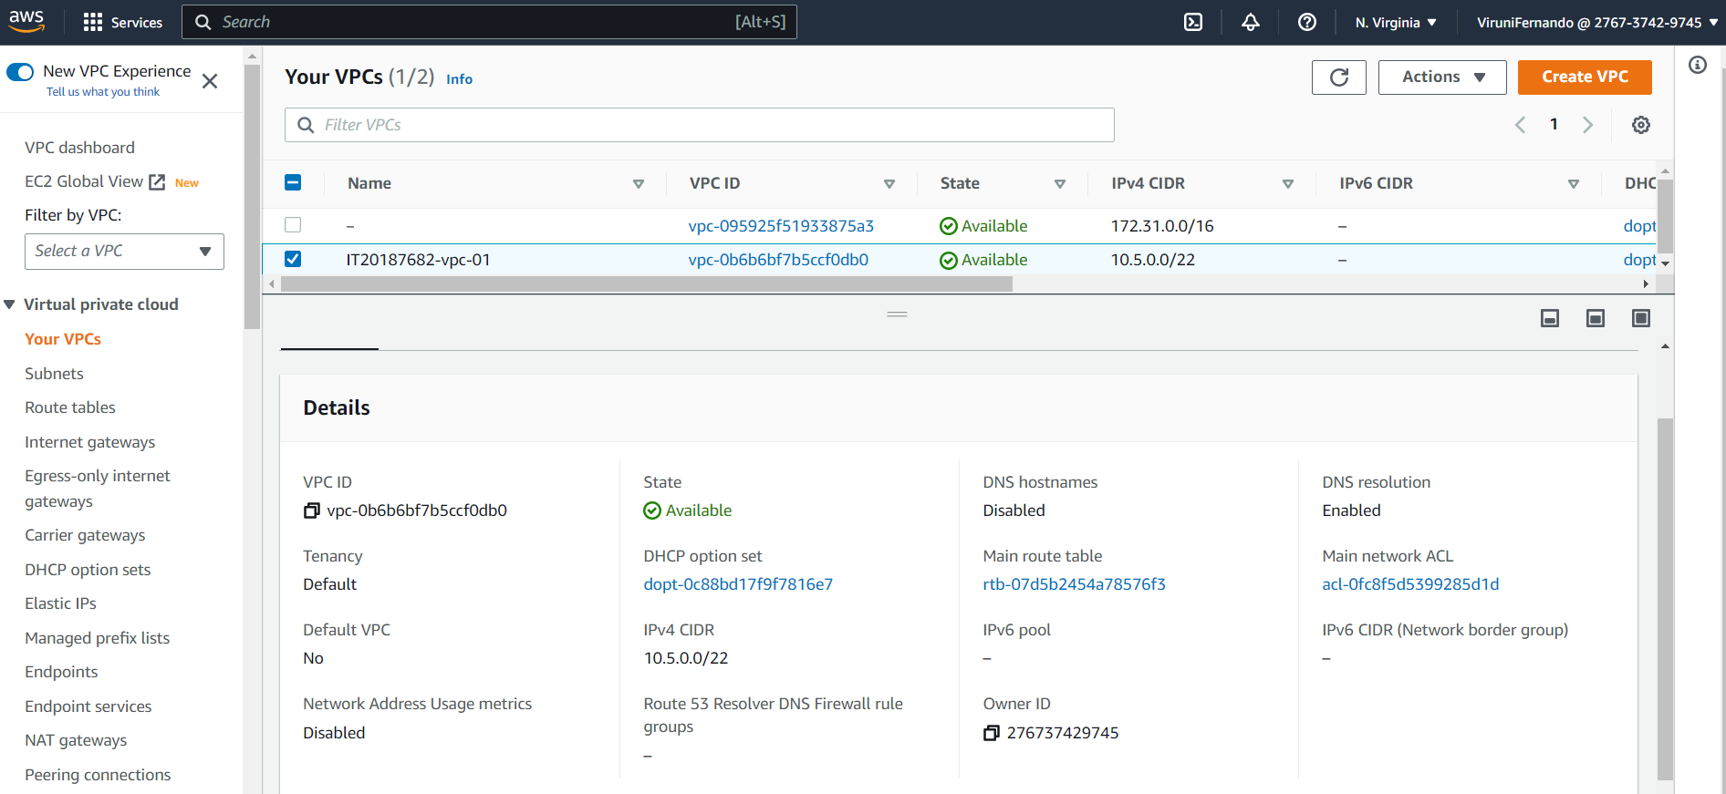

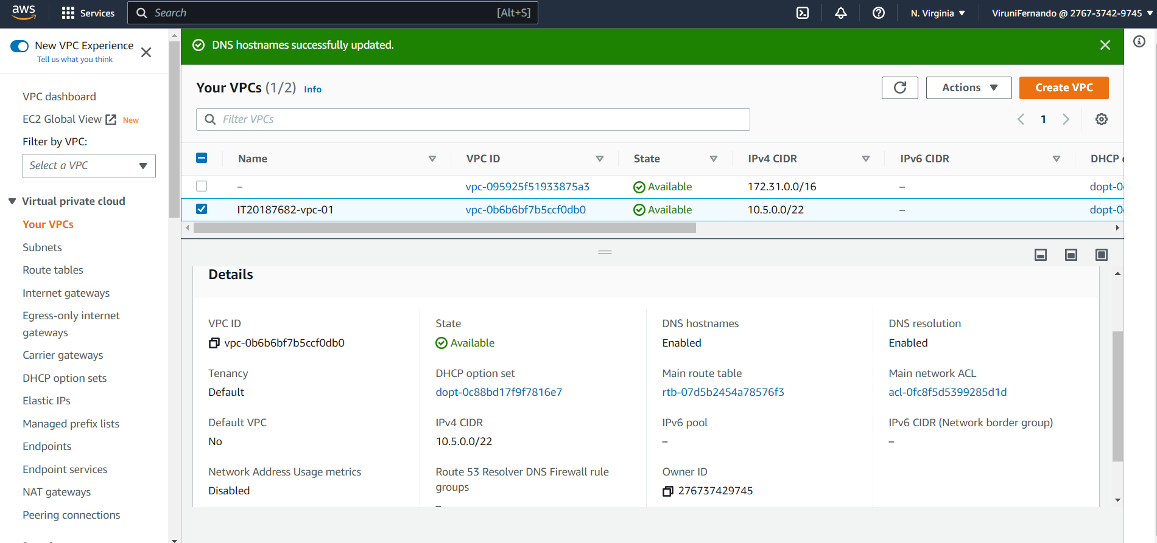

2. Create Subnet

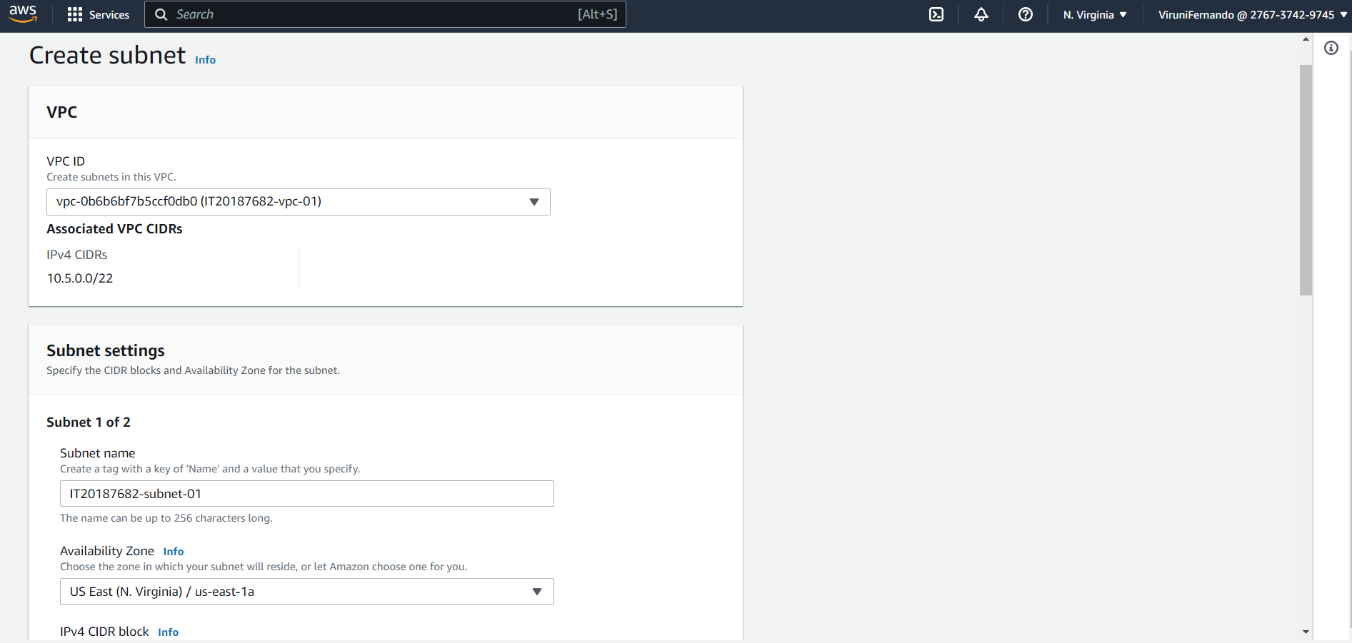

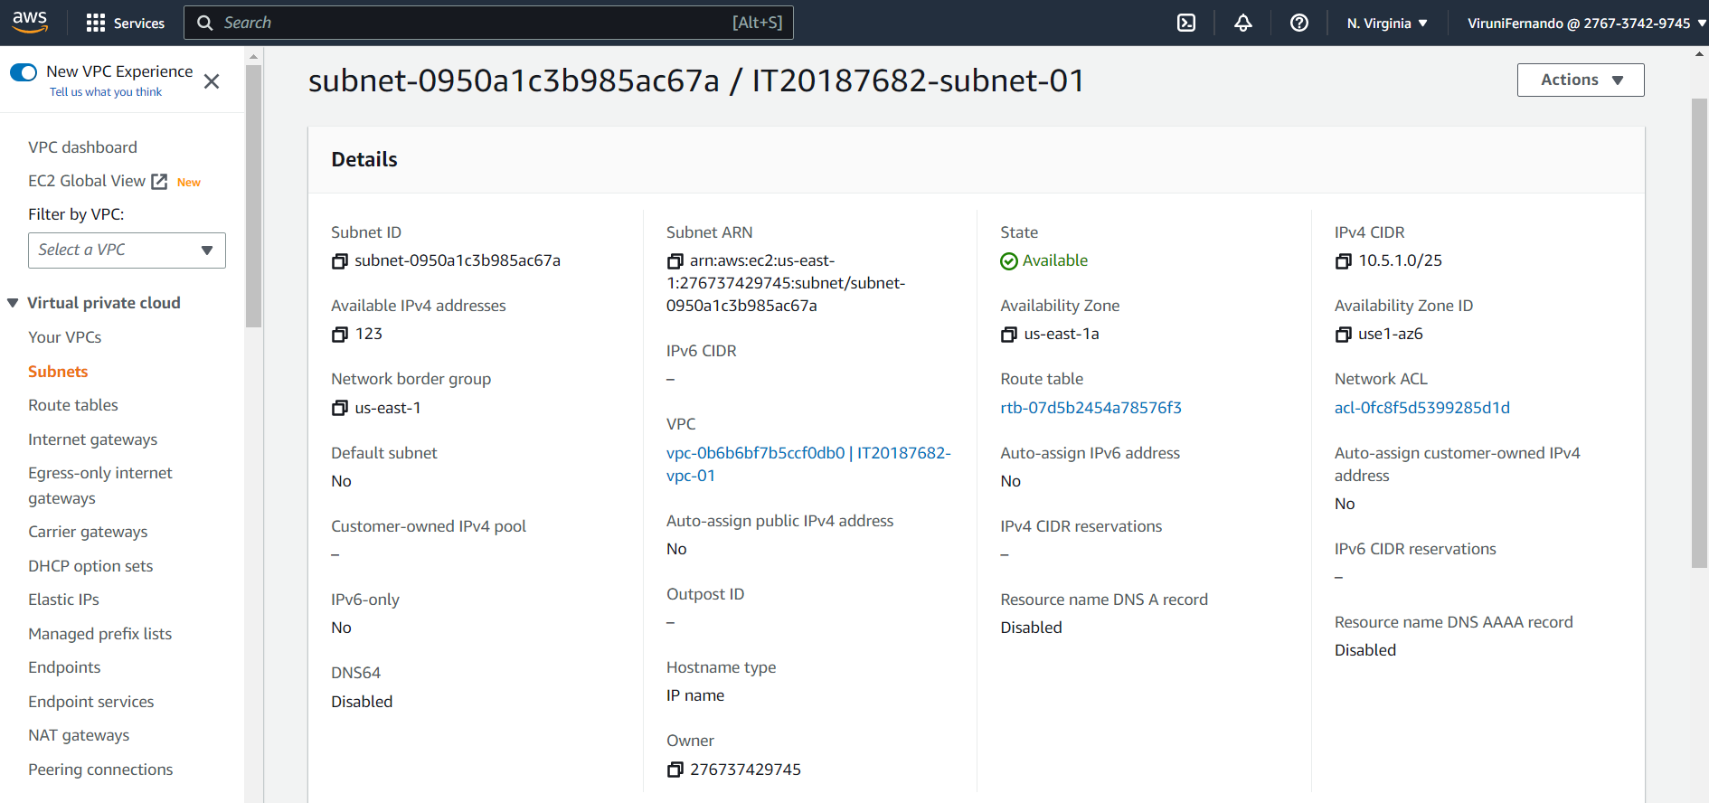

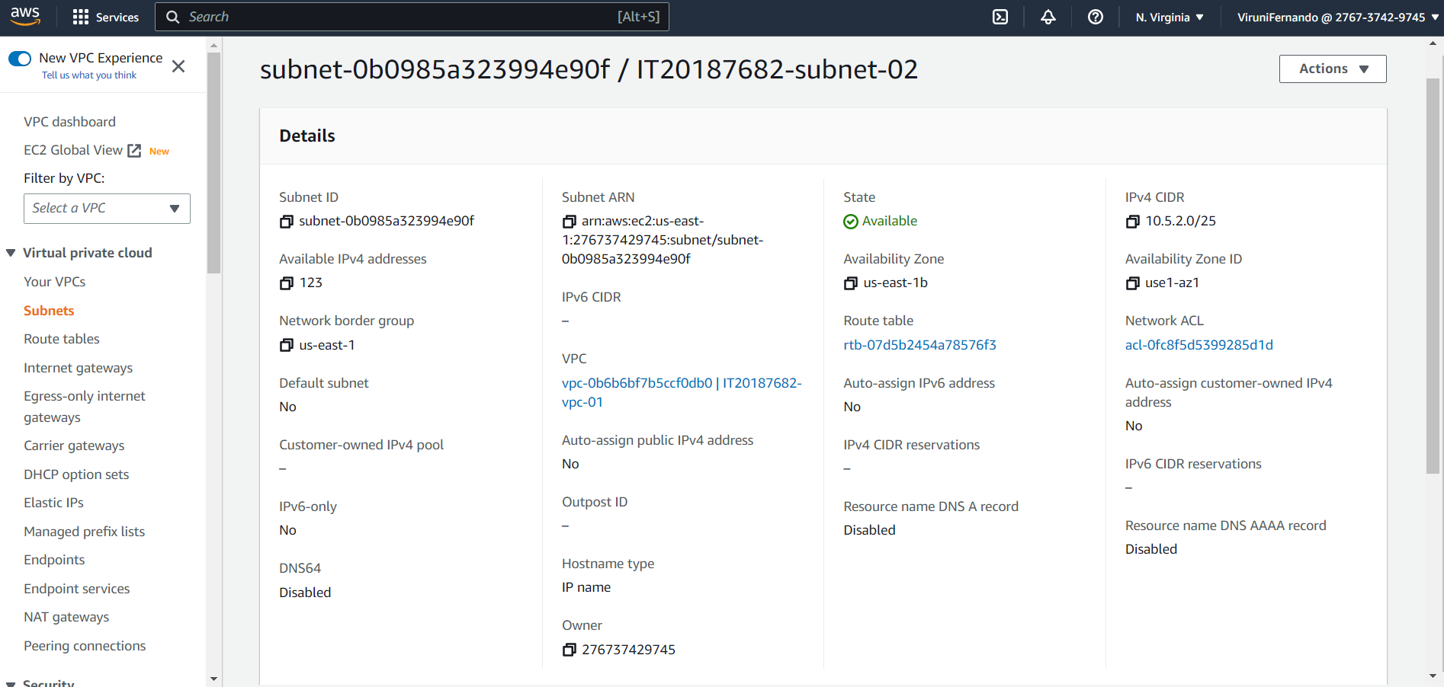

3.Create Internet Gateway

4.Create Route Tables

5. Create Security Group

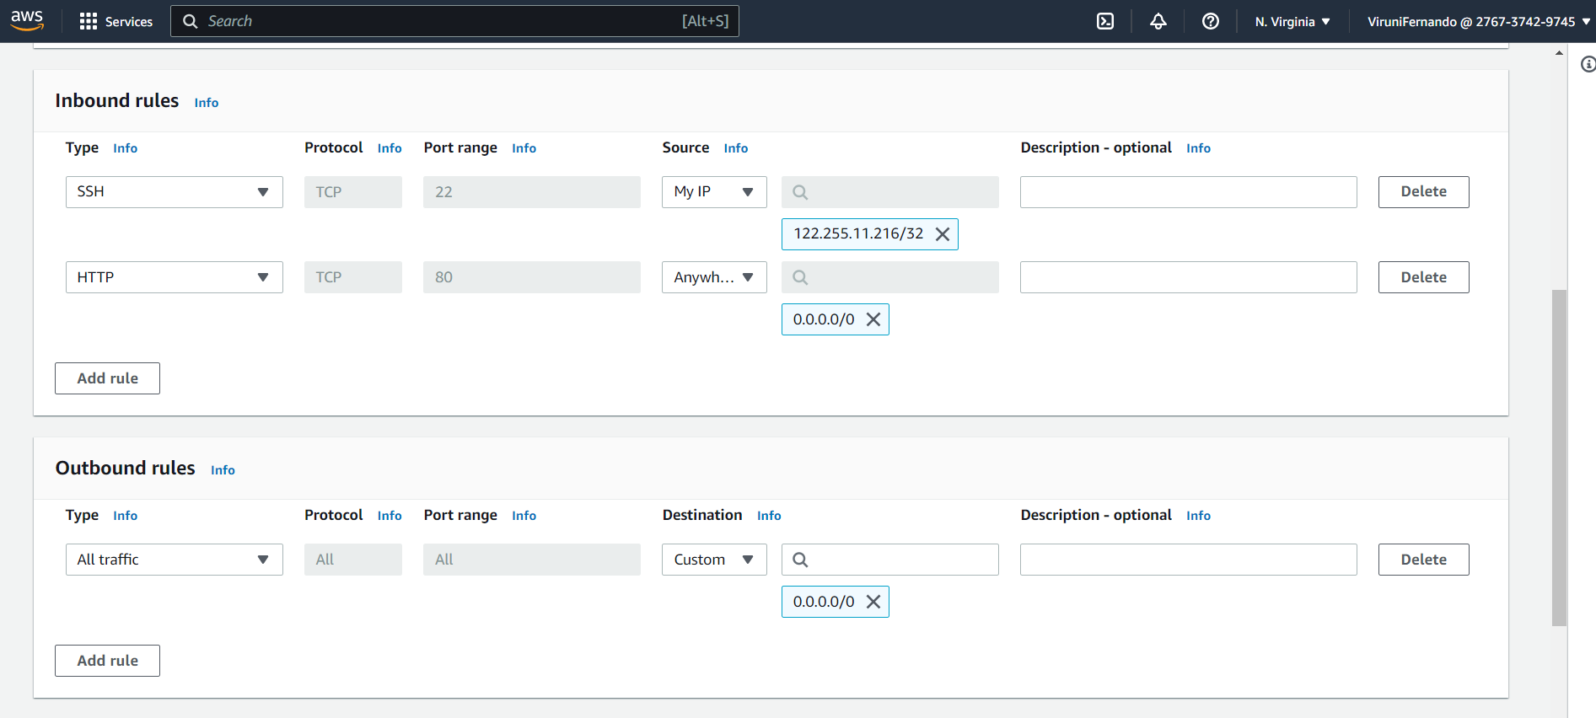

6.Create Launch Configuration (auto scaling)

7.Creating Load balancer

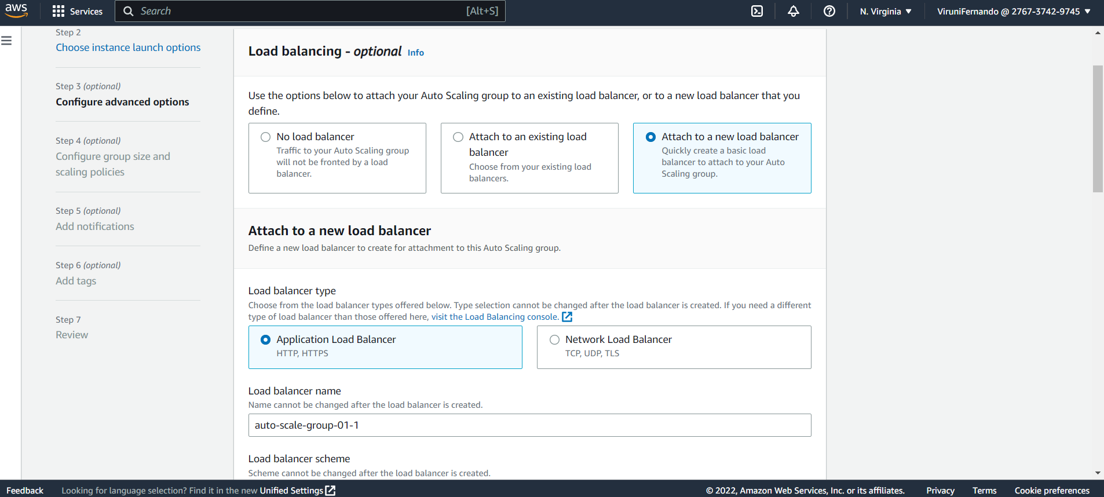

8.Security group

9.Install Apache

